Final Report Outline

Project Title: Sales Management Database Application
Course: Database Systems
Student: Omar Mehraby, Walid Boiub, Aya Zentari
Supervisor: Dr.lamiaeBouanae
Institution: Al Akhawayn University
Academic Year: 2024–2025

Table of Contents

- Introduction
- Project Objectives
- Project Planning
- Design
4.1 Conceptual Design
4.2 Requirements Specification
4.3 Business Rules, Entities, and Relationships
4.4 Initial E-R Model
4.5 Table Normalization
4.6 Final E-R Model
4.7 Logical Design
- Implementation
5.1 Database Creation and Population
5.2 SQL Queries and Procedural SQL
5.3 Views
5.4 Stored Procedures, Functions, and Triggers
5.5 Application Architecture
- Testing and Fine-Tuning
- User Manual
- AI Use
- Conclusion
- Future Work

1. Introduction
This project consists of designing and implementing an Sales Management Database Application. The system manages sales transactions including products, categories, regions, and sales amounts. The database supports data storage, querying, aggregation, and visualization through a user-friendly application interface.
The organization operates in a retail context where sales data must be stored reliably, queried efficiently, and analyzed to support decision-making. Key constraints include data consistency, correctness of aggregations, and clarity of outputs.

2. Project Objectives
The main objectives of this project are:
- To design a well-structured relational database
- To apply proper normalization techniques
- To implement SQL queries that satisfy business requirements
- To build an application interface connected to the database
- To ensure correctness through testing and validation

3. Project Planning
The project was carried out in several phases:
- Requirements analysis
- Conceptual and logical database design
- Normalization and dependency analysis
- Database implementation and population
- Application development
- Testing and validation

4. Design

4.1 Conceptual Design
The conceptual design identifies the main entities involved in the system and the relationships between them. The core entity is Sales, which captures transactional data.

4.2 Requirements Specification
The system must allow:
- Insertion of sales records
- Retrieval of sales data
- Aggregation of sales amounts
- Grouping of sales by product, category, and region

4.3 Business Rules, Entities, and Relationships

1. User Management Rules
- Every User must have a unique UserID, a username, a password hash, a creation date, and a user type.
- A User is either an Admin User or a Business User, but cannot be both at the same time (disjoint specialization).
- A Business User belongs to exactly one department.
- An Admin User has an assigned administrative level.
- Only registered users can request manual reporting tasks.

2. Task and Trigger Rules
- Every Report Task must have a unique TaskID, a start time, a status, and a task type.
- Each Report Task is associated with one and only one Report Trigger.
- A Report Trigger may initiate multiple Report Tasks.
- A Report Task must be classified as either:
  - an Automated Task, or
  - a Manual Task.
- Automated tasks are executed automatically by the system without user intervention.
- Manual tasks must be requested by exactly one User.
- A user may request multiple manual tasks.

3. Reporting and Summary Rules
- Each Report Task may generate one Summary Report.
- A Summary Report must be generated from exactly one Report Task.
- A Summary Report includes aggregated metrics such as:
- total sales
- total transactions
- average sale value
- top product, category, and region
- weakest category
- highest sale
- sales trend
- A Summary Report must include a generation timestamp.
- Summary reports are read-only and cannot exist without their corresponding report task.

4. Automation and Logging Rules
- Each Report Task may generate multiple Automation Log entries.
- Every Automation Log entry must be associated with exactly one Report Task.
- An Automation Log records system events such as execution status, messages, and timestamps.
- Automation logs are automatically created by the system and cannot be manually modified by users.

5. Data Source Rules
- Every Data Source must have a unique SourceID, a source type, and a creation date.
- A Data Source must be classified as either:
- a File Upload, or
- an API Source.
- A File Upload data source includes file name, upload date, and row count.
- An API Source includes an endpoint and a data retrieval frequency.
- A Data Source may contain multiple sales records.

6. Sales Data Rules
- Each Row Sale record must have a unique SaleID.
- Each sale record must include:
- sale date
- sale amount
- product
- category
- region
- Every sale record must be associated with exactly one Data Source.
- Sale amounts must be numeric and non-negative.
- Sales data cannot exist independently without a valid data source.

7. Integrity and Consistency Rules
- Deleting a Report Task automatically invalidates its associated summary report and logs.
- Deleting a Data Source is restricted if sales records exist for that source.
- The system ensures referential integrity between all related entities through foreign keys.
- The database enforces consistency through primary keys, foreign keys, and specialization constraints.

4.4 Initial E-R Model

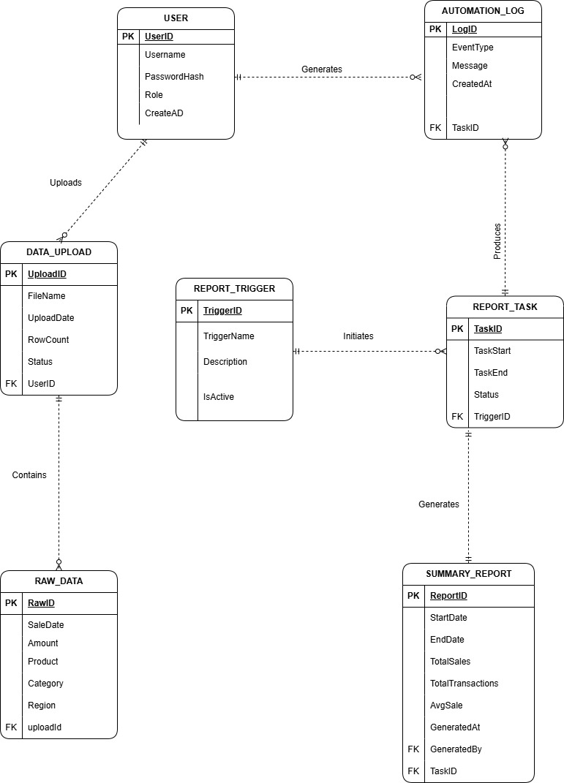
The initial E-R model represents the relationships between entities before normalization. It includes all attributes necessary to describe sales transactions.

4.5 Table Normalization
Normalization was applied up to Third Normal Form (3NF):
- 1NF: Elimination of repeating groups
- 2NF: Removal of partial dependencies
- 3NF: Removal of transitive dependencies
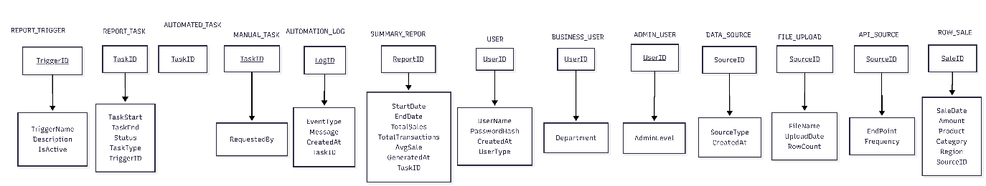
A dependency diagram was used to identify and eliminate functional dependencies.

4.6 Final E-R Model

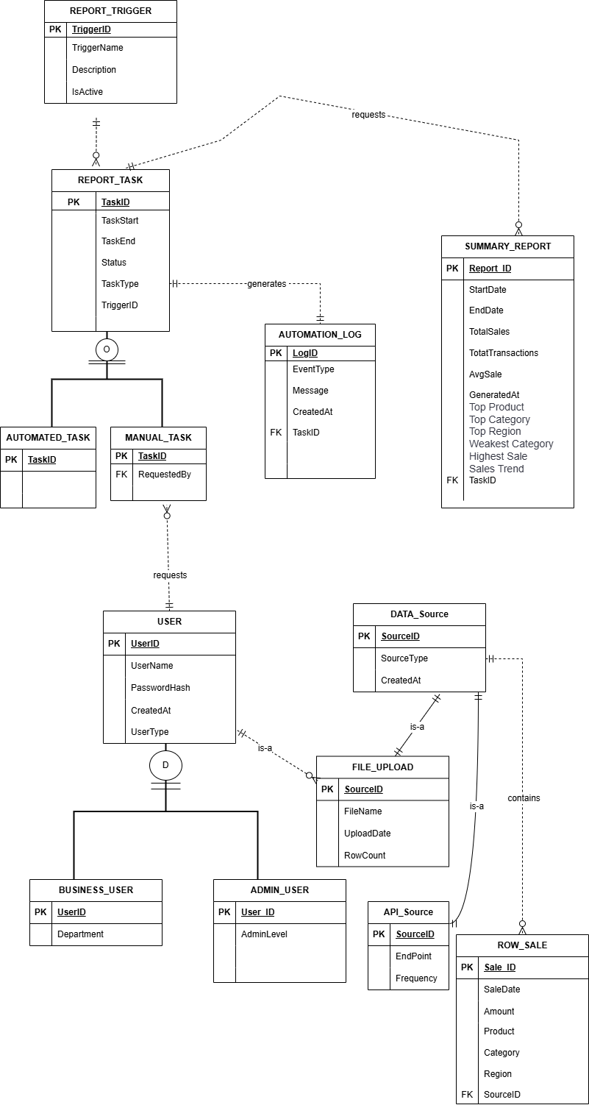

The final E-R model reflects a normalized structure with clearly defined primary keys and foreign keys, ensuring data integrity and minimal redundancy.

4.7 Logical Design
The logical design translates the E-R model into relational tables with defined attributes, data types, primary keys, and constraints.
\

5. Implementation

5.1 Database Creation and Population
The database was implemented using PostgreSQL. Tables were created based on the logical design and populated using a CSV dataset containing 45 rows of sales data.

5.2 SQL Queries and Procedural SQL
The following types of queries were implemented:
- Retrieval queries (SELECT)
- Aggregate queries (SUM, GROUP BY)
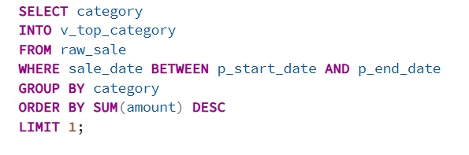
- Data manipulation queries (INSERT, UPDATE, DELETE)
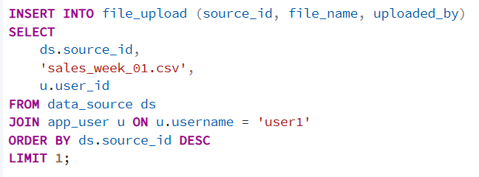
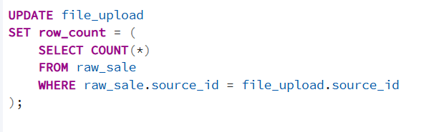
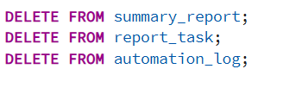
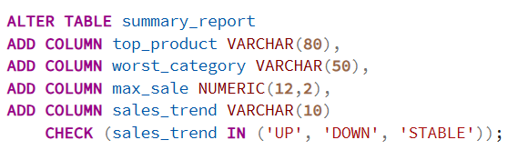

5.3 Views
Views were created to simplify access to commonly used aggregated data, such as Sales by category.

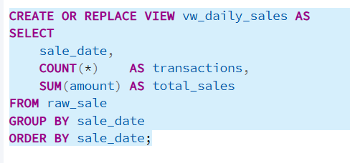

5.4 Stored Procedures, Functions, and Triggers
Stored procedureand functions were implemented to encapsulate logic and improve reusability. Triggers were used to maintain data integrity during updates and deletions.

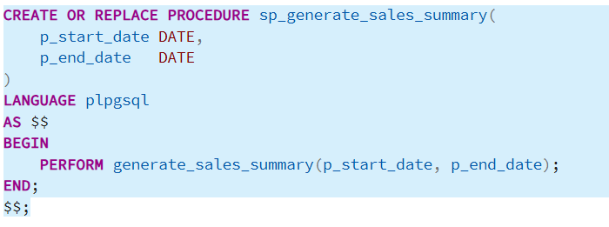

CREATE OR REPLACE FUNCTION generate_sales_summary(

p_start_date DATE,

p_end_date DATE)

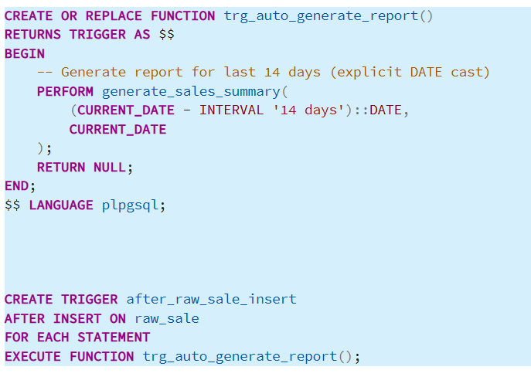

5.5 Application Architecture
The application architecture consists of:
- PostgreSQL database
- pgAdmin for database management
- A Python-based application (Streamlit) for user interaction

6. Testing and Fine-Tuning
Testing included:
- Validation of inserted data
- Verification of query results
- Checking aggregation correctness
- Handling NULL values and constraints
All outputs were validated against expected results.
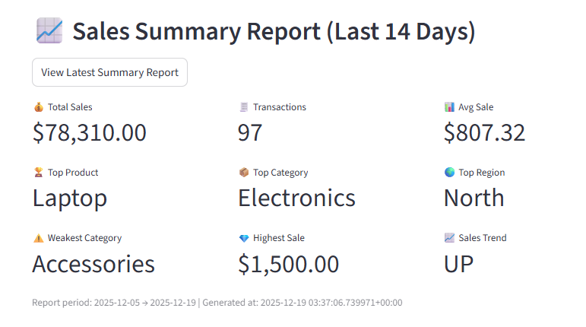
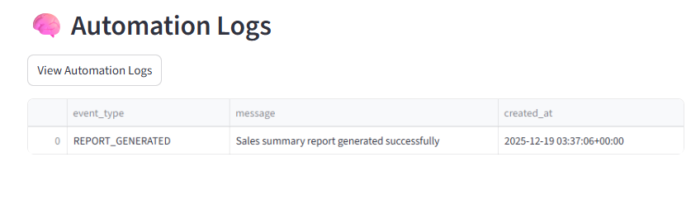

7. User Manual
The application provides:
- Forms for data visualization
- Tables displaying sales records
- Summary metrics such as total sales
Screenshots of the interface are included to illustrate user interaction.

8. AI Use
AI tools were used to assist in:
- Code optimization
- Query validation
- Documentation structuring
AI was used as a support tool while all design and implementation decisions were made by the student.

9. Conclusion
This project successfully demonstrates the complete lifecycle of database development, from requirements analysis to implementation and testing. The final system is functional, well-structured, and meets all specified requirements.

10. Future Work
Possible future enhancements include:
- Adding user authentication
- Implementing advanced analytics dashboards
- Extending the schema to support inventory management
- Integrating real-time data updates

